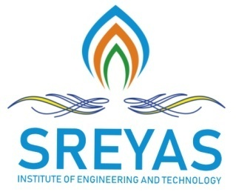**Sreyas Institute of Engineering and Technology**

***An Autonomous Institution***

Approved by AICTE, Affiliated to JNTUH

Accredited by NAAC-A Grade, NBA (CSE, ECE & ME) & ISO 9001:2015 Certified

## Department of Computer Science and Engineering

## IV-II CSE -MAJOR PROJEC: 2023-24

**Date:**

To

The HOD,

CSE Department,

Sreyas Institute of Engineering and Technology.

**Subject** – Regarding interaction of all batch members with Major Project Internal Guide.

We, the members of Batch A2 from IV CSE – A section, have interacted with our Major Project Internal Guide on a regular basis and discussed the Major Project Review, also verified with the status of Major Project.

After verification, our guide has approved the review PPT of the Project.

Hereby, we are informed to proceed for presentation of Major Project Review-II to the respective Panel Members.

**TITLE OF THE PROJECT** – An Implementation of Block Chain Technology in Forensic Evidence Management

**DOMAIN OF THE PROJECT** – Block Chain

**Batch Members –**

|  |  |
| --- | --- |
| **ROLL NUMBER OF THE STUDENTS** | **NAME OF THE STUDENTS** |
| 20VE1A0535 | BHAVANI KONGARI |
| 20VE1A0525 | INUGANTI SRI CHARAN |
| 21VE5A0505 | MEGHANA KACHARA |
| 20VE1A0538 | MARRI VARUN GOPAL REDDY |

**INTERNAL GUIDE**

**PROJECT COORDINATOR HOD-CSE**